Faiza Abdullah

Lab 03 on MSLE Skillable Platform

ITAI 2376 Deep Learning in Artificial Intelligence

Professor: [Patricia Mcmanus](https://eagleonline.hccs.edu/courses/282423/users/264039)

**REFLECTIVE JOURNAL: ANALYZE TEXT IN AZURE AI FOUNDRY PORTAL**

**PROOF OF COMPLETION:**

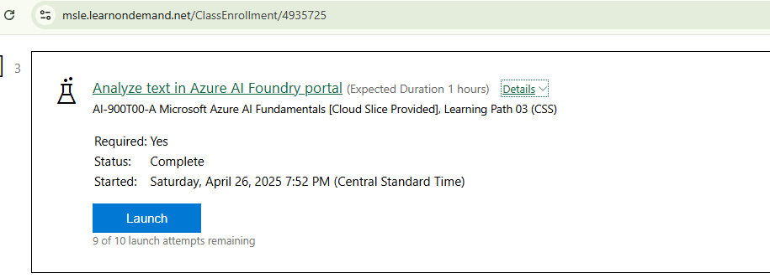

**INTRODUCTION**

In this lab, I explored the Azure AI Language service within the Azure AI Foundry portal. The primary focus was on utilizing Natural Language Processing (NLP) to analyze text, specifically hotel reviews, and extract valuable insights. This lab provided a hands-on experience with Azure AI Language, demonstrating its capabilities in real-world scenarios.

**LAB OBJECTIVES AND PROCESS**

The lab aimed to familiarize with setting up a project in the Azure AI Foundry portal and using the Language service to analyze hotel reviews.

**WHAT I DID**

* Accessed the Azure AI Foundry Portal on the Microsoft Learn on Demand platform and initiated the process by creating a new project, providing a workspace for the subsequent text analysis tasks.

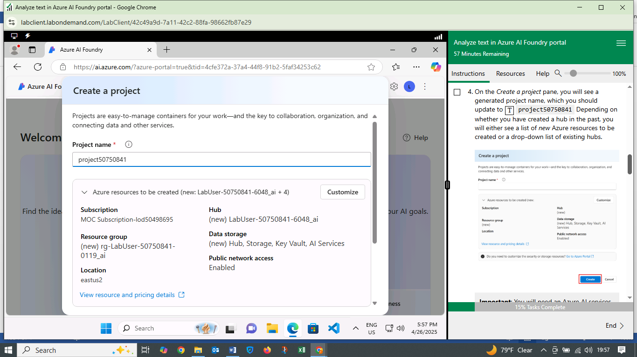

* Accessed Language Playground, an interactive environment that allows users to experiment with various language processing features.

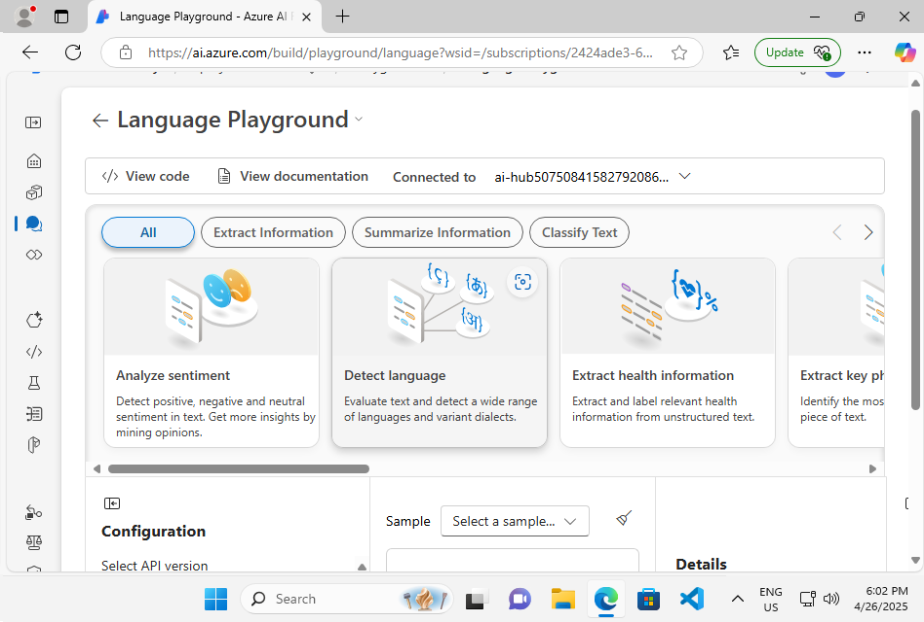

* “Extracted Named Entities” feature was used to identify and categorize key elements within the text, such as locations, organizations, and other relevant entities. For example, in the hotel review “Tired hotel with poor service. The Royal Hotel, London”, the service identified “hotel” and “London”.

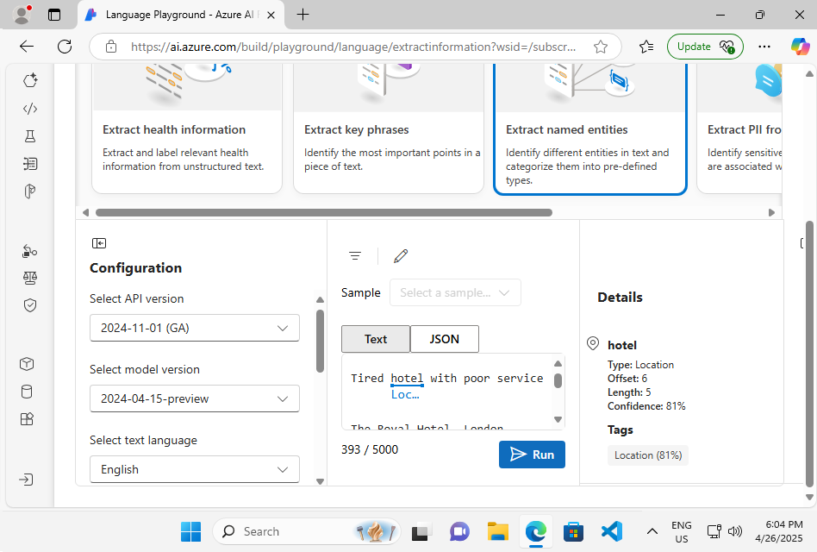

* “Extracted Key Phrases” functionality was employed to pinpoint the most important points in the text. This process helps in quickly grasping the main themes of the review, such as “Good Hotel” and “staff” from the provided review text.

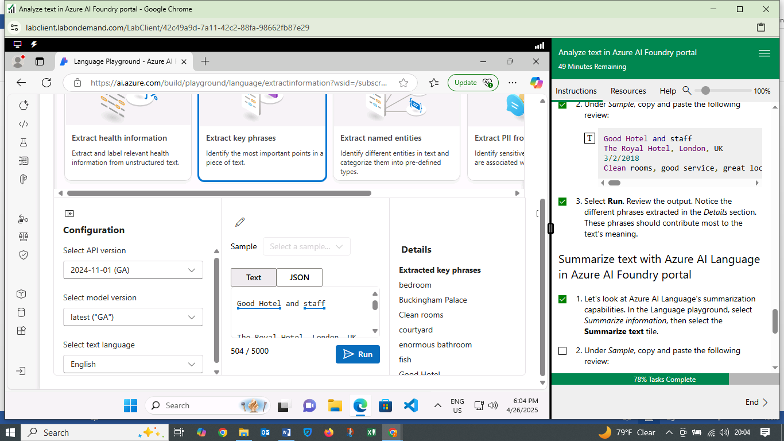

* Utilized “Summarized Text” to generate concise summaries of longer reviews. This tool extracts the most salient sentences, providing a condensed version of the original text. For instance, the tool summarized a hotel review, highlighting the key complaint: “Very noisy and rooms are tiny.”

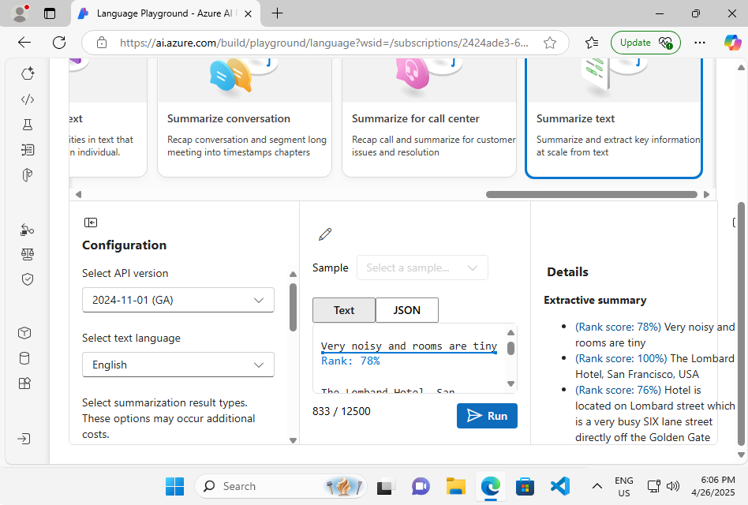

The lab demonstrated how Azure AI Language can be used to analyze hotel reviews. I created a project, accessed the Language Playground, and used features like entity extraction, key phrase extraction, and text summarization. For example, the tool identified "hotel" and "London" as key entities, extracted "Good Hotel" and "staff" as important phrases, and summarized a review to "Very noisy and rooms are tiny."

**WHAT I LEARNED**

* Capabilities of Azure AI Language: I gained an understanding of how Azure AI Language can process and analyze text to extract meaningful information. The service's ability to identify entities, key phrases, and generate summaries showcases its versatility.
* Practical Applications of NLP: The lab illustrated how NLP can be applied to real-world problems, such as analyzing customer feedback to improve services.
* User-Friendly Interface: The Azure AI Foundry portal, particularly the Language Playground, provides an intuitive environment for experimenting with language processing tasks.
* Efficiency of Text Analysis: The lab highlighted how Azure AI Language can automate and streamline the process of analyzing large volumes of text, saving time and effort.

**CHALLENGES FACED**

* Initial Portal Navigation: Navigating the Azure AI Foundry portal to locate the Language service required some initial exploration.
* Understanding Different Features: Differentiating between the various text analysis features and understanding their specific applications required careful review of the lab instructions.
* Interpreting Results: While the Language service provides clear outputs, interpreting the nuances of the extracted information sometimes required a deeper understanding of the context.

**INSIGHTS GAINED**

* Power of NLP: The Azure AI Language service demonstrated the power of NLP in extracting valuable insights from unstructured text data.
* Customization: Azure AI Language can be customized for specific business needs, such as sentiment analysis of customer reviews or topic modeling of documents.
* Efficiency in Decision-Making: The ability to quickly analyze and summarize text can significantly improve the speed and accuracy of decision-making processes.
* Integration with Other Azure Services: Azure AI Language can be integrated with other Azure services to build comprehensive AI solutions.

**CONCLUSION**

Completing the Azure AI Language lab was a valuable experience as I learned about NLP, customization, and efficiency will be valuable in my future work with Azure AI technologies. The challenges faced were manageable and provided opportunities to deepen my understanding of text analysis using cloud-based AI.